Wireless Bridge

📶 What is a Wireless Bridge?
# Source: Chatgpt (GPT‑5 Mini) at [12/18/2025]
A Wireless Bridge is a device or configuration that connects two or more separate network segments wirelessly, allowing them to communicate as if they were connected by cables. It functions like a standard Layer 2 bridge, but instead of Ethernet cables, it uses Wi-Fi radio signals.
✅ A Wireless Bridge is often used to link two buildings or network zones without running Ethernet cables.

🔄 What It Does
# Source: Chatgpt (GPT‑5 Mini) at [12/18/2025]
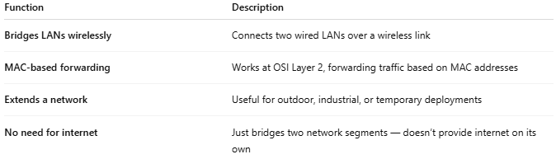
Function | Description
Bridges LANs wirelessly | Connects two wired LANs over a wireless link
MAC-based forwarding | Works at OSI Layer 2, forwarding traffic based on MAC addresses
Extends a network | Useful for outdoor, industrial, or temporary deployments
No need for internet | Just bridges two network segments — doesn’t provide internet on its own

📶 Wireless Bridge Setup Example
# Source: Chatgpt (GPT‑5 Mini) at [12/18/2025]
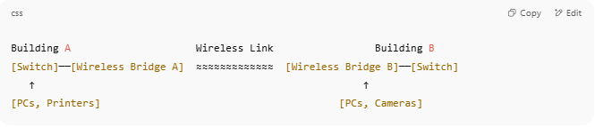

Building A Wireless Link Building B
[Switch]──[Wireless Bridge A] ≈≈≈≈≈≈≈≈≈≈≈≈≈ [Wireless Bridge B]──[Switch]
↑ ↑
[PCs, Printers] [PCs, Cameras]

- Wireless bridges connect Ethernet switches or routers between locations.
- Devices in both buildings can share files, printers, and servers as if they were on the same network.

📦 Types of Wireless Bridges
# Source: Chatgpt (GPT‑5 Mini) at [12/18/2025]
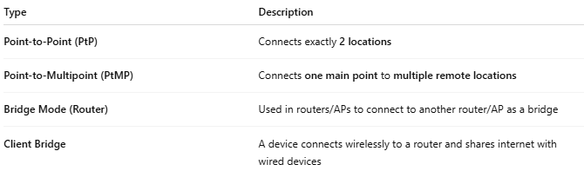

Type | Description
Point-to-Point (PtP) | Connects exactly 2 locations
Point-to-Multipoint (PtMP) | Connects one main point to multiple remote locations
Bridge Mode (Router) | Used in routers/APs to connect to another router/AP as a bridge
Client Bridge | A device connects wirelessly to a router and shares internet with wired devices

🛠️ Typical Use Cases
# Source: Chatgpt (GPT‑5 Mini) at [12/18/2025]
- Connecting two buildings on a campus
- Extending a network across parking lots, warehouses, or open spaces
- Adding Wi-Fi or LAN access in detached rooms or guest houses
- Surveillance cameras in outdoor areas

🆚 Wireless Bridge vs Wi-Fi Repeater/Extender
# Source: Chatgpt (GPT‑5 Mini) at [12/18/2025]
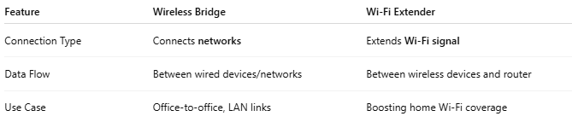

Feature | Wireless Bridge | Wi-Fi Extender
Connection Type | Connects networks | Extends Wi-Fi signal
Data Flow | Between wired devices/networks | Between wireless devices and router
Use Case | Office-to-office, LAN links | Boosting home Wi-Fi coverage

✅ Pros
# Source: Chatgpt (GPT‑5 Mini) at [12/18/2025]
- ✅ Eliminates the need for long Ethernet cables
- ✅ Easy to set up with outdoor antennas or mesh systems
- ✅ Maintains full Layer 2 functionality (VLANs, etc.)
- ✅ Ideal for permanent or temporary network extensions

❌ Cons
# Source: Chatgpt (GPT‑5 Mini) at [12/18/2025]
- ❌ Performance affected by distance and obstacles
- ❌ Signal interference can reduce stability
- ❌ Not ideal for high-throughput needs over long distances without line-of-sight

🏷️ Popular Brands/Models
# Source: Chatgpt (GPT‑5 Mini) at [12/18/2025]


Brand | Example Wireless Bridges
Ubiquiti | NanoStation, NanoBeam, AirFiber
TP-Link | CPE210, CPE710
MikroTik | LHG, SXTsq
Netgear | WBC502, Orbi Bridge mode

📌 Summary
# Source: Chatgpt (GPT‑5 Mini) at [12/18/2025]
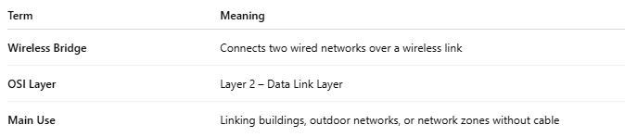
Term | Meaning
Wireless Bridge | Connects two wired networks over a wireless link
OSI Layer | Layer 2 – Data Link Layer
Main Use | Linking buildings, outdoor networks, or network zones without cable

